Sacramento City Unified School District

Elder Creek Elementary School

Explore. Dream. Discover.

PARENT HANDBOOK
2021-2022
7934 Lemon Hill Avenue
Sacramento, CA 95824
Phone: (916) 395-4555
Website: https://eldercreek.scusd.edu/
Brandon Frink, Principal
Vue Xiong, Assistant Principal
School Vision:
All students will achieve academic success, become productive citizens, and lifelong learns through the establishment of a culture of high expectations and a safe student-centered environment and with the support of staff, parents, and community.

Mission statements:
- Promote positive character development and increase awareness of healthy styles.
- Promote global, independent and collaborative, thinkers and learners.
- Strengthen ties with the community and promote family involvement.
- Prepare students to be college and career ready by establishing high standards and challenging goals.
- Utilize multiple sources of student data to drive instruction.

Table of Contents
General Information | 3
Arrival and Departure Guidelines | 3
Attendance and Absences | 4-6
Uniform Policy | 7
Emergency Information Cards | 8
Cell Phones, Electronics Equipment, and Personal Items | 8
Skateboards, Scooters, Skateshoes, and Rollerblades | 9
Cafeteria & Wellness Policy Information | 9-11
Student Discipline Policy | 12-13
Anti-Bullying Policy | 15-16
Textbooks | 17
Visitors | 18
Volunteers on Campus | 19-20
Technology | 21

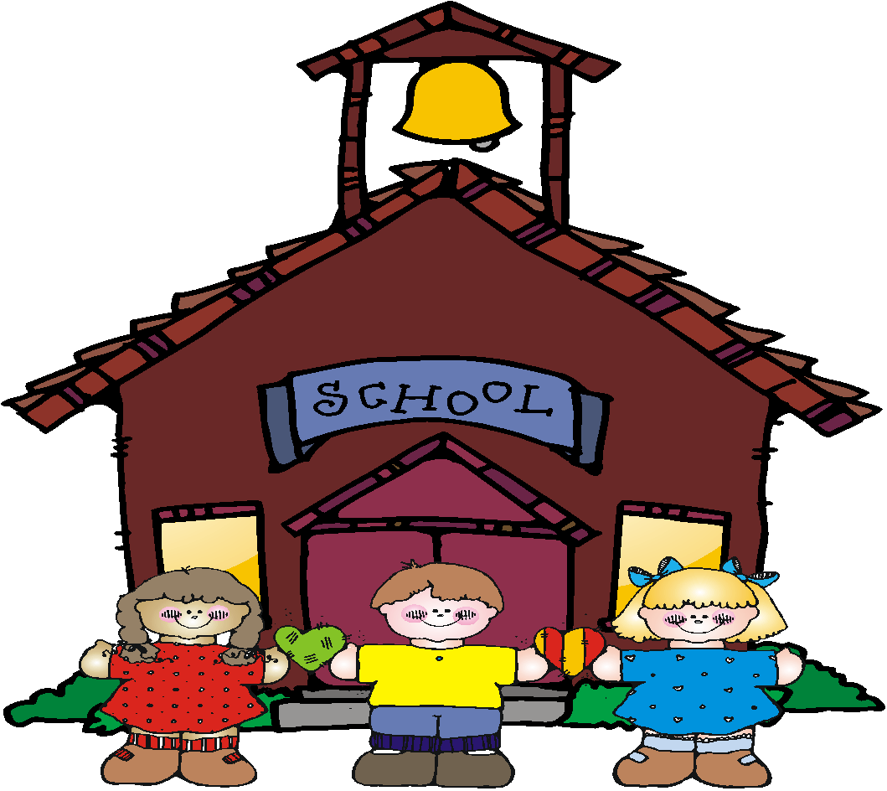
General Information

Office Hours: 7:30 a.m. – 4:00 p.m.

School Hours:

AM Kindergarten M-F 8:00 AM-11:30 AM

Chinese Immersion Kindergarten M-F 8:00 AM-12:00PM

Grades 1st-6th M, T, W, F 8:00 AM-2:02 PM - Thu: 8:00 AM-1:02 PM

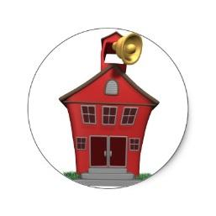Arrival and Departure Guidelines

BEFORE SCHOOL

- Students are NOT to arrive at school prior to 7:30 a.m.
- Breakfast starts at 7:30 a.m.
- Students must wait in front of the East gate (big parking lot).
- Drop off areas are in the East gate, West gate, and the Loading/Unloading zone on Lemon Hill Ave.
- The front office is not to be used as an entrance by students.

AFTERSCHOOL

- Students are to leave the campus immediately after school unless they are in a classroom for tutoring, enrolled in the afterschool program, or participating in a supervised after school program/activity.
- Students loitering on campus will be referred to the office.
DROP OFF/PICK UP PROCEDURES
- Students are to be picked up at the East gate, the West gate, and the Loading/Unloading zone on Lemon Hill. Kindergarten students are to be picked up inside the enclosed Kindergarten play area or at the East gate.

PARKING

- Please do not leave your vehicle unattended in the loading zone. The area is designated for dropping off students only.
- To ensure the safety of our students, please follow the directions of the traffic and crossing guard.

Attendance and Absences

- One of the most important aspects of successful learning is regular, on-time attendance at school.
- Please send a note, call the school, or send an email to the school to excuse your child’s absences.
- Vacations must be scheduled during the summer. If the student is gone for over 10 days, the student will be disenrolled.

CALIFORNIA STATE ATTENDANCE LAWS

Compulsory Education E.C. 48200. Each person between the ages of 6 and 16 years is subject to compulsory full-time education.
Excused Absences E.C. 46012. Excused absences are as follows: illness, quarantine, medical, dental, optometric services and funerals. Parents/guardians MUST write an excuse stating the reason for each absence.
Truant Pupils E.C. 48260. Any pupil subject to compulsory full-time education who is absent from school without a valid excuse for more than three days or is tardy in excess of 30 minutes on each of more than three days in one school year is classified as truant and shall be reported to the attendance supervisor or to the superintendent of the school district.
The parent or guardian is obligated to compel the attendance of the pupil at school.
The parents or guardians who fail to meet this obligation may be guilty of an infraction and subject to prosecution pursuant to Section 48290, Chapter 2, of Part 27.

Truancy:
- If a student has 3 or more unexcused absences or 3 tardies of 30 minutes or more, he/she is considered truant.
- SCUSD’s truancy program includes a partnership with the District Attorney, Sacramento Police, Juvenile Probation, City of Sacramento and several judges.
  - The process involves letters sent home, a school site SART meeting and a district level SARB (Student Attendance Review Board) hearing.
  - It is our goal to make sure every student has the opportunity to receive a quality education: therefore, we will do everything possible, prior to a hearing, to improve attendance. However, if attendance concerns continue the District is prepared to implement the SARB process to the fullest extent.
  - Please note that an absence may still be considered unexcused even though a parent call is made.

Excused Absences:
- Verified illness of student.
- Quarantine of student under direction of health officer.
- Personal medical or dental appointment.
- Attending funeral service of parent, sibling, grandparent, or any relative living in the immediate household of the child. (limited to 1 day in the state and 3 days out of state)
- Exclusion due to incomplete immunization. Parents/Guardians have 10 days to provide evidence of immunization. After 10 days student is excluded from school and recorded as absent for no more than 5 days.
- Religious service

Unexcused Absences:
- Vacations
- Oversleeping
- Babysitting or taking care of other family members
- Personal reasons (car trouble, parents have an appointment)
- Waiting for service or repair people
- Attending a sporting event
- Shopping
- Going to a concert
Tardiness
- School begins at 8:00 A.M. Students are expected to be at school and in class before the tardy bell rings.
- Students must bring a tardy note, obtained from the office, to the teacher in order to be admitted to class.

Early Dismissal
- Students can be released from school early upon the request of a parent/guardian. However, this is permitted on a “need basis” only and should not occur on a regular basis.
- Parent(s), or a person identified on the student’s emergency card, must sign the student out in the office before the student may leave the campus.
- Students are encouraged to return to school after dental/doctor appointments.
- The office staff will call for the student to come to the office to meet the parent/guardian.
- In order to ensure the safety of our students and staff, no one, other than office staff, is allowed to go directly to the classroom without signing in at the office first.
Ways to Report an Absence:

When your child is absent from school you have two weeks to report an absence.

You can report absences 4 ways:
- Call the school office at (916) 395-4555.
- Turn in a note to the office.
- Email our Office Manager (TBA)
- Submit the absence on our website: http://eldercreek.scusd.edu/
  - Go to Quick Links
  - Click on Report an Absence
  - Submit information

UNIFORM POLICY

Elder Creek has a mandatory uniform policy which supports the following:

- Creates a safer school and enhances the learning environment.
- Fosters student achievement and positive behavior amongst students.
- Provides a sense of family pride within the school.
The regulations for wearing uniforms or unacceptable attire are:
- Students are expected to wear white or navy blue collared top and navy blue/khaki and dark denim bottom daily. Uniforms can be purchased at K-Mart, Target, Walmart, Family Bargain Center, and other department stores.
- Shirts, blouses, and pants may not have any writing on them unless they are Elder Creek spirit shirts.
- All students must wear regulation uniform attire every day (except for authorized “free dress days”).
- Students out of uniform will be required to call home for a change or will be loaned a loaner shirt. Appropriate clothing must then be brought to school that day.
- Students who wear non-regulation outer attire will be directed to remove the garment and it will be kept until the end of the day.
- Second offenses will require that the parent /guardian pick up the garment.
- In addition, any items that may impede student learning will not be permitted, such as false fingernails, make-up, fake tattoos, etc.
ACCEPTABLE
- Uniform must be clean and well-fitting
- Solid white or navy blue polo shirt, turtleneck or blouse, or Elder Creek shirt
- Solid white or navy blue sweatshirt or sweater or Elder Creek sweatshirt
- Solid navy blue/khaki pants, shorts, skirts, dresses, or jumpers
- Solid colored jackets/coats (preferably navy blue or white)
- Closed-toe shoes with socks (e.g., tennis shoes, boots or loafers)
- Solid colored hats (except red or blue) when cold out with no emblems (worn outside only)

UNACCEPTABLE:
- Tank tops and midriff tops
- Open-toed shoes and heels
- Clothing with inappropriate symbols or words
- Faded and/or ripped jeans

.
Emergency Information Cards

- Every student is required to have a complete and up-to-date emergency card on file in the front office.
- Should an emergency arise, the school staff will make every reasonable effort to contact the parent or guardian of the student.
- Parents are asked to sign the medical release statement. Without the medical release form and parent/guardian signature, doctors and hospitals can refuse to provide emergency treatment, even when school personnel accompany the student.
- Any changes in phone numbers and addresses must be recorded on the emergency card. The card is critically important in the event of an emergency.
- Children will not be released to anyone not authorized on the emergency card.
Students without an up-to-date emergency card on file will not be allowed to participate in field trips until an up-to-date card is on file.

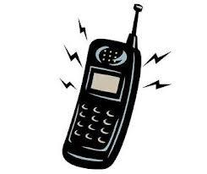Cell Phones, Electronic Equipment, and Personal Item

- The school will not be responsible for lost, damaged or stolen electronic equipment or personal items brought to school from home. While cell phones may be brought to school they may NOT interfere with the instructional process.
- Cell phones are to remain off and out of sight (in backpacks) at all times while on campus.
- Students may use cell phones only when instructed by a school authority in the event of an emergency.
- Phones or electronic equipment used inappropriately will be confiscated and a parent/guardian must come pick up the item in the front office.

Skateboards, Scooters, Skateshoes, and Rollerblades

- Skateboards, scooters (includes electric scooters), skate shoes, and rollerblades are not allowed on school grounds.
- A first violation of this rule will result in confiscation of the equipment, which will be returned at the end of the day; after all other violations a parent will be required to pick up the item.
- It is the law that students wear helmets when riding anything with wheels.
- Bikes must be walked on campus at all times.

Cafeteria Information

- The authorizing legislation and programs regulations clearly intend that meals reimbursed under Federal and State Nutrition Programs be served and consumed by the enrolled child under direct supervision by a District employee during regular school hours as part of the program, on school or school related premises.

✔District Wellness Policy Information All Grades

Please see the link below, that includes links to the policy, and many resources developed by the District Wellness Policy Committee – a group of dedicated parents, community partners, teachers and district staff.
https://www.scusd.edu/district-wellness-committee
“A Wellness Policy is an important tool for parents, educational agencies and school districts in promoting student wellness, preventing and reducing childhood obesity, and assuring that school meal nutrition guidelines meet the minimum federal school meals standards. It contains goals specifically for nutrition promotion and education, physical activity, and other school based activities that promote student wellness.” –USDA
Frequently Asked Questions:
What may be served and sold on campus?
Foods and beverages served and sold in schools must meet strict federal and state regulations for calories, saturated fat, sodium, sugar and trans fat. For an easy-to-use list, visit www.scusd.edu/wellnesspolicy.
When are these regulations in effect?
PreK-8th grade: Regulations are effective from midnight to a half hour after the school day or expanded learning (whichever is later).
High schools: Regulations are effective from midnight to a half hour after the school day.
How can you tell which foods are compliant?
Other than fresh fruits and vegetables, which are always compliant, food compliance varies widely. Use the California Project Lean calculator to determine compliance of items: www.californiaprojectlean.org
To whom do these regulations apply?
These federal and state regulations apply to Non-Charter Public Schools participating in the National School Lunch Program.
Can I bring snacks for the class on my child’s birthday or general classroom celebration?
Yes, as long as the snack meets state and federal regulations for food served during the school day, such as fresh fruit, 100% fruit juice and whole grain snacks. Most cupcakes/cakes do not meet these requirements. Other non-food related options are possible, including but not limited to pencils, erasers, or other small items.
Do these regulations apply to food items that students bring from home for their own personal consumption?
No – Parents may decide what food items they want their own child to have.
May teachers give students candy/food as a reward for good behavior?
No – BP 3050 Student Wellness Policy restricts the use of food for rewards. The district as a whole wants to limit access to unhealthy items during the school day that decay teeth and teach unhealthy lifelong habits.
Do these regulations apply to sports games and parent-sponsored events?
Concessions sold at a sporting events may begin 30 minutes after the school day ends at any grade level.
The regulations do not apply to food sold to adults.
These regulations do not apply to food sold at events held in the evenings or on weekends.
Fundraising:
School student-organizations must comply with all food and beverage standards. This includes how many items they can sell, pre-approval of the items, when they can sell, how many sales can be done per year, and more.
The regulations apply to food sold and served to students before school, during the school day and until 30 minutes after the conclusion of any extended learning program for EK – 8th grade schools.
These regulations apply to food sold and served to students before school, during the school day and until 30 minutes after the conclusion of the standard school day for 9-12th grade schools.
Classroom Celebration Ideas:
SCUSD employees, parent organizations and outside organizations will not use any food or beverage as a reward, incentive or punishment for academic performance or good behavior. Schools can promote a positive learning environment by shifting the focus from food during classroom celebrations, and striving to have non-food celebrations or healthy non-allergenic food. Food must be compliant with Competitive Foods regulations.
Healthy snack options:
• Fresh fruit
• Smoothies
• Frozen bananas with shredded coconut
• Vegetables with a variety of healthy dips (hummus, guacamole, salad dressing)
Awesome Celebration Ideas:
• Games, such as relays
• Hold class outdoors
• “Free choice” time
• Stickers/pencils
• Balloons/bubbles
• Art supplies/projects
• Read a story
• Movie day

Student Discipline Policy

STATE LAW REQUIRES THAT ALL PUPILS OBEY AND COOPERATE WITH ALL MEMBERS OF THE SCHOOL STAFF

- Parents are asked to review with their children the importance of obeying and cooperating with the school staff (this includes teachers, secretaries, teacher aides, yard duty supervisors, and custodians).
- All school staff are here to provide your child with an orderly and safe environment for learning and they need the parent and child’s support and cooperation.
- The school has a responsibility to hold students to strict account for their behavior and conduct on the way to and from school, in the classroom and during recess.

School Rules:

1. Be Respectful
2. Be Responsible
3. Be Productive
4. Be Safe

Behavior Expectations
Area/Setting | Be Safe | Be Responsible | Be Respectful
Arrival | 1. Walk to the cafeteria or playground. | 1. (Parents) Do not bring your child to school before 7:30 so we can have supervision in place | 1. Wait patiently for the gate to be opened.
Cafeteria | 1. Speak quietly  2. Walk quietly out of the cafeteria.  3. Observe the Quiet Coyote signal. | 1. Pick up your trash.  2. Wait until you are dismissed.  3. Keep food in the cafeteria. | 1. Use proper table manners  2. Help pick up any trash around you.  3. Be kind to others.
Playground/Recess | 1. Freeze and squat when the bell rings.  2. Walk to your line  3. Follow adult directions.  4. No food allowed on the playground. | 1. Stay within the designated areas.  2. Stay within the red lines.  3. Do not put your backpacks on the ground. | 1. Share play equipment.  2. Put back play equipment.  3. Keep hands and feet to yourself.  4. No play fighting.
Hallway | 1. Walk | 1. Do not play in hallways. | 1. Let others pass safely
Line | 1. Wait quietly for your teacher. | 1. Keep your hands and feet to yourself. | 1. Walk quietly behind the person in front of you.
Bathrooms | 1. Flush toilet and wash hands after using the bathroom. | 1. Throw paper towels in the trash cans  2. Inform an adult if there is a problem. | 1. Keep bathroom clean at all times.
Dismissal | 1. Walk immediately to Target Excellence or the exit gate. | 1. Do not play around school campus.  2. Watch for your ride. | 1. Do not distract other classrooms.  2. Be on time.
Office | 1. Speak quietly | 1. Get permission from staff before entering. | 1. Wait patiently  2. Use please and thank you.
Technology | 1. Do not make any changes to the laptops without teacher approval. | 1. Take care of computer equipment.  2. Keep your work area neat and clean. | 1. Raise your hand if you have a question.  2. Enter and exit quietly.

Consequences:

Students who violate school rules may face one of the following consequences:
- Warning
- Time Out/loss of recess
- Conference with student and/or parent
- Lunch time or all day detention
- School Community Service (e.g., trash pick-up)
- Suspension (in-house suspension or formal)

SUBSTANCE- FREE CAMPUS

Elder Creek Elementary School is an alcohol, tobacco, and drug free campus. No student or adult is allowed to use these substances at any time on any part of the school campus. We want to keep our campus free of these substances as a positive example to our students.

Any student who intentionally sells, gives, possesses, uses, or is under the influence of illicit drugs, narcotics, or alcohol on school property shall be recommended for expulsion from school and reported to the appropriate law enforcement agencies for possible legal action.

PARENT NOTIFICATIONS

The Board further prohibits the use of tobacco products at all times on district grounds. This prohibition applies to all employees, students and visitors at any activity or athletic event on property owned, leased or rented by or from the district.

The Superintendent or designee shall inform students, parents/guardians, employees and the public about this policy and related procedures.

ENFORCEMENT PROCEDURES FOR VISITORS

A visitor who smokes on district property shall be informed of the district's tobacco-free schools’ policy and asked to refrain from smoking. If the person fails to comply with this request, the following actions may ensue:

1. The matter may be referred to the Superintendent or designee responsible for the area or the event.
2. The Superintendent or designee may direct the person to leave school property.
3. If necessary, the Superintendent or designee may request local law enforcement assistance in removing the person from school premises.
4. If the person repeatedly violates the tobacco-free schools policy, the Superintendent or designee may prohibit him/her from entering district property for a specified period of time.
(cf. 3515.2 - Disruptions)

Anti-bullying Policy

The Governing Board desires to provide an orderly, caring and nondiscriminatory learning environment and specifically prohibits acts of harassment or bullying. The Governing Board has determined that a safe and civil environment in school is necessary for students to learn and achieve high academic standards. Harassment or bullying, like other disruptive or violent behaviors, is conduct that disrupts both a student’s ability to learn and a school’s ability to educate its students in a safe environment. Demonstration of appropriate behavior, treating others with civility and respect, and refusing to tolerate harassment or bullying is expected of administrators, faculty, staff, parents, students and volunteers to provide positive examples for student behavior.

Harassment or bullying is any gesture or written, verbal, graphic, physical or electronic act (i.e. including, but not limited to, internet, cell phone, personal digital assistant (pda), or wireless hand held device) that is reasonably perceived as being motivated either by any actual or perceived characteristic, such as race; color; religion; ancestry; national origin; gender; sexual orientation; gender identity and expression; socioeconomic status; academic status; mental, physical, development or sensory disability or impairment; creed; political belief; age; linguistic or language differences; height; weight; marital status; parental status; or by any other distinguishing characteristic; or because of an association with a person who has or is perceived to have one or more of these characteristics. Such behavior is considered harassment or bullying whether it takes place on or off school property, at any school-sponsored function, in a school vehicle, or by students, family members or staff.

Students shall be assured that they need not endure, for any reason, any harassment which impairs the educational environment or a student's emotional well-being at school. Harassment involves unwelcome comments (written or spoken) or conducts which violates an individual's dignity, and/or creates an intimidating, hostile, degrading, humiliating or offensive environment.

Students shall be assured that they need not endure, for any reason, bullying behavior, including electronic or cyber bullying, which impairs the educational environment or a student’s emotional well-being. Bullying is a comprehensive term that describes conduct that meets all of the following criteria: is directed at one or more persons; substantially interferes with educational opportunities, benefits, or programs of one or more students; adversely affects the ability of a student to participate in or benefit from the school district’s educational programs or activities by placing the student in reasonable fear of physical harm or by causing emotional distress; is based on a student’s actual or perceived distinguishing characteristic (see above), or is based on an association with another person who has or is perceived to have any of these characteristics;
Involves an imbalance of power or strength; and involves a pattern of behavior repeated over time

Electronic bullying or cyber bullying is the use of electronic communication technology such as, but not limited to, e-mail, instant messages, text messages, mobile phones, and web sites, to send or post messages or images to embarrass, humiliate, spread rumors, threaten or intimate. Sending sexually explicit images electronically, even consensually, may be considered as distribution of child pornography, and is to be referred to district security and/or law enforcement.

The District prohibits bystander support of harassment or bullying as it can encourage and/or reinforce the behavior. Bystander support may be active actions such as, but not limited to, laughter or calling attention to the situation; or through passive actions such as, but not limited to, watching the situation and doing nothing.

The Board prohibits reprisal or retaliation against any person who reports an act of harassment or bullying. The consequences and appropriate remedial action for a person who engages in reprisal or retaliation shall be determined by the administrator after consideration of the nature, severity, and circumstances of the act.

Elder Creek Site Bullying Policy

Elder Creek prohibits bullying and harassment in any form and follows the SCUSD anti-bullying/harassment policy. All staff, teachers, students, and parents are asked to report incidents of suspected bullying or harassment immediately to the principal/AP so that an investigation can take place. The principal/AP will then determine if the act meets the district’s anti-bullying policy and follow through on consequences/solutions. Retaliation towards students or others who report bullying or harassment is prohibited. For more information go to http://www.scusd.edu/pod/report-bullying-behavior.

Textbooks
Textbooks are provided for use by students and remain the property of the Sacramento City Unified School District. Students are responsible for returning textbooks checked out in their name in good condition, with no more wear and tear than usually results from normal use. (SCUSD BP 6161.2)

Each student is responsible for all textbooks checked out under his/her name and is subject to fines if books are lost or damaged. Students or parents/guardians are responsible for the current replacement cost of the materials. (SCUSD BP 6161.2 and CA Education Code 48904)

Payment can be made by cashier’s check, money order or cash. Checks for lost or severely damaged books are made out to Sacramento City Unified School District. If the book(s) are later found (within 9 months) and returned, a refund check will be issued by the district. A receipt must be presented in order to receive a refund.

Fines may be waived in instances of unusual circumstances at the discretion of the principal, his/her designee or the district. Or, students may complete service hours in lieu of cash payment for damaged or lost textbooks.

When materials are damaged but still usable the student will be charged as follows:
Damages | Cost
Torn pages, ink or pencil marks | $1.00 per page
Damaged cover | 25% of the cost of the book
Damages that prevent re-issuing books (including mold or mildew or obscenities – drawn or written) | Full cost of the book
Missing bar codes | $5.00

All textbooks must be returned by students at the end of every school year. If not, the district may withhold the student’s grades, diploma, and transcripts until restitution is made or an agreement is reached with the site administration. (CA Education Code 48904). The student may also be denied participation in school privileges or commencement activities. (SCUSD BP 6161.2)
Visitors

- Elder Creek encourages parents / guardians and interested members of the community to visit the school and view the educational program. All visitors will be issued a badge that identifies them as a guest at our school. Please be sure to sign out when leaving the campus.

To ensure minimum interruption of the instructional program:

- Visits during school hours should be first arranged with the teacher and principal.
- If a conference is desired, an appointment should be set with the teacher during non-instructional time.

To ensure the safety of students and staff and avoid potential disruptions:
- All visitors shall register immediately upon entering any school building or grounds when school is in session.
- All visitors must sign in at the school office where an identification badge will be provided.
- Please be aware that youth under the age of 18 are not permitted to be on campus without an adult.

We appreciate your adherence to these procedures and contributing to
the safety and welfare of our students.

Volunteers on Campus

Rules and Regulations
Below is a summary of Administrative Regulation (AR 1240) and School Board Policy (BP 1240) that are relevant to SCUSD volunteers.

SCHOOL VOLUNTEERS

Parents, guardians, and community members are encouraged and welcomed to volunteer at Elder Creek Elementary School. To volunteer, interested persons will need to complete the following steps:

- Fill out a Volunteer Registration form, Contact Reference form, and Reference Release form,
- Obtain a referral form from the school office personnel to get a free T.B. (Tuberculosis) skin test
- Return T.B. skin test results to the school. The T.B. skin test results must be negative.

Who are considered volunteers?
A volunteer is a parent, community member or other adult who assists at a school site or program on a regular semi-regular basis. Also parents who observe or visit their child at school on a routine basis and stay more than 15 minutes each time are considered volunteers. Authorized parents / guardians are not prohibited from visiting their child’s classroom or school campus if
that visit is in compliance with Board policy, school rules and applicable law. A parent picking up their child from school or occassionally observing or visiting their child’s school is NOT considered a volunteer.

Volunteer Categories & Requirements: Volunteer work WILL NOT begin until school receives clearance

Level I - Off Campus Volunteers – No Direct Supervision

Activities may include: Telephoning other parents / correcting papers at home / performing off campus work, etc.
Requirements: Complete a volunteer registration form only (retrieve from front office), sign in at office daily once cleared

Level II - Volunteers under direct supervision **

Activities may include: these volunteers are under the immediate supervision & direction of certificated personnel & are not allowed to be left alone with students outside the presence (visibility) of a certificated employee. Instructional or office aids/small group assistance/special projects/meal assistance/classroom help, etc.
Requirements: Complete a Volunteer Registration form, Sex Offender clearance form (SOC1) and TB test (retrieve from front office), sign in at office daily once cleared

Level III - Volunteers NOT under direct supervision, with possible unsupervised contact w/students

Activities may include: these volunteers may or may not remain under the immediate supervision & direction of certificated personnel & are allowed to be left alone with students outside the presence (visibility) of a certificated employee. One-on-one tutoring / chaperoning field trips / transporting students in private vehicle/special projects, etc.
Requirements: Complete a Volunteer Registration form, Fingerprinting & Criminal Record Clearance form (BC1), TB test, [and volunteer personal automobile use form if transporting students (RSK-F106E)] (retrieve from front office), sign in at office daily once cleared

Exclusion of Volunteers:
- Any person who is required to register as a sex offender shall not serve as a volunteer
- Any person who has been convicted of a serious or violent felony shall not serve as a volunteer
- Also, any person arrested for a serious or violent crime shall not serve as a volunteer in a child care or child development program. For any other conviction, the Superintendent or designee has the discretion to deny volunteer service depending on the nature of the conviction as it relates to the volunteer’s duties

Expectations for Adult Behavior
Any adult behavior that interferes with the discipline, good conduct and lawful performance of school activities may result in a withdrawal of consent, for 14 days, to remain off campus in accordance with California Penal Code Section 626.4(a) (enclosed).

California Education Code considers the following to be misdemeanor offenses:

- Willful disturbance of any public school or any public school meeting. California Education Code Section 32210.
- Willful interference with the discipline, good order, lawful conduct, or administration of any school class or activity of the school with the intent to disrupt, obstruct or to inflict damage to property. California Education Code Section 44810.
- Conduct which disrupts classwork or extracurricular activity or involves substantial disorder. Education Code Section 44811.

Any behavior that creates a disruption of classroom or school activities, or disturbance of any school employee, may result in a misdemeanor and subject the perpetrator to arrest. In addition, the District will consider further lawful proceedings, such as obtaining a temporary restraining order and other civil action to maintain safety and order on campus. The District will seek reimbursement for attorney costs the courts may impose.

Technology

Rules for Use of Computers and Computer Networks. When you use school computers, you agree to:

1. Follow the directions of teachers and school staff.
2. Abide by the rules of the school and school district.
3. Obey the rules of any computer network you access.
4. Be considerate and respectful of other users.
5. Use school computers for school-related education and research only.
6. Not to use school computers and networks for personal or commercial activities (gaming or Email).
7. Not change any settings, software or documents (except documents you create).
8. Not download any programs unless instructed by teacher.

Use of school computers and access to the Internet is a privilege.
1. If you do not follow the rules, you will be disciplined and lose your computer privileges.

Do not produce, distribute, access, use, or store information, which is:
1. Unlawful
2. Private or confidential
3. Copyright protected
4. Harmful, threatening, abusive, or denigrates others
5. Obscene, pornographic, or contains inappropriate language
6. Interferes with or disrupts the work of others
7. Causes congestion or damage to systems

Protect your password
1. Do not allow anyone else to use your password and do not use anyone else’s password

Sacramento City Unified School District
Internet and Electronic Communication
(E-mail) Non-Use Policy
Please fill this out if you do not want your child to have access to the internet.

ELDER CREEK SCHOOL
My child is NOT allowed access to Internet privileges while in a school environment. I understand that alternative methods are available for completing assignments.

___________________________________
Child’s Name

___________________________________
Parent/Guardian Signature Date
Please return to your child’s school.

** Site administrators are to place this document with original signatures in the student’s folder.
✂ ✂ ✂ ✂ ✂ ✂
ELDER CREEK SCHOOL PARENT & STUDENT HANDBOOK
I have read and discussed the Elder Creek Handbook with my son/daughter. We are aware of, and agree to follow, the behavior expectations of Elder Creek School.

__________________________________________
Print Student’s Name

__________________________________________
Student Signature

__________________________________________
Parent/Guardian Signature

_________________ ________________
Room Number Date

Please sign, cut and return the right side of this page to your son/daughter’s teacher.

